Helping your child to become an independent writer.
Many parents have been asking how to help their child at home with their writing.
The children are working very hard at school to be able to write independently. This is a requiremnet in order for them to reach a “Good level of Development “ at the end of Foundation 2.
At school we do not copy write eg copying a sentence written by an adult and we do not spell out the words ( dicatate the spellings) to the children. This would not be described as writing independently.
At this stage your child is using his/her phonic knowledge to write words in ways which match their spoken sounds.
For example, the sentence
“I went to the shops with my sister” may be written
“I wt to the shp wif my sista”
This is exactly what we would hope to see. The child has thought of a sentence, listened to the sounds that they can hear themselves and has written them independently.
Here are some examples of the writing that we are doing at the moment. Some examples are working towards the Early Learning goal and some have met the criteria.
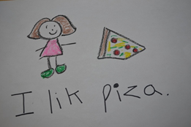 | 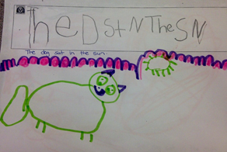 | 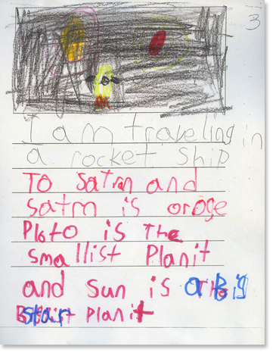

How can you help at home?
Writing for a purpose is the most effective way of developing early writing skills. Here are some ideas that you could use at home.
- Asking your child to write the shopping list.
- Asking your child to write message reminders e.g. Don’t forget my book bag for school. Your child may write this sentence like this – Dnt forgt my buk bag for scl. This is exactly what we would expect. Writing for a purpose is the most effective way of encouraging a child to write.
- Labelling their toys.
- Writing cards or sending postcards from holiday.

We are using the Phase 2 and Phase 3 phonics in our writing. You can use the sound mats at home to help your child with their writing.

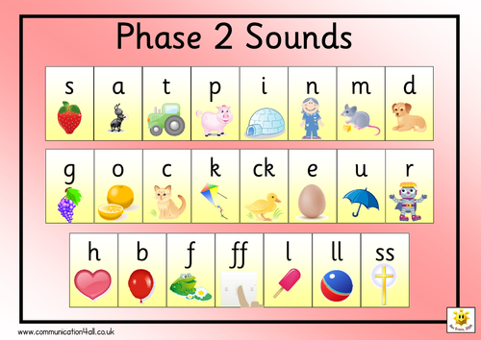
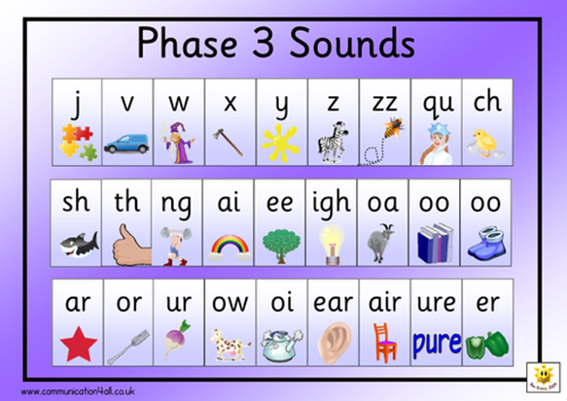
We hope that you found todays “Funky Phonics” Stay and Play useful. If you have any questions or would like more advice, please ask a member of the Foundation Team.

