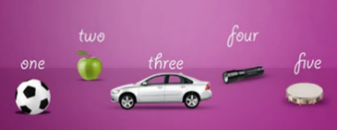
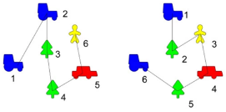
Counting a deceptively simple skill
Counting is such a basic tool to us that it is easy to assume that children know what they are doing as they count, or what we mean when we ask “How many?“

During the Foundation years we concentrate on the counting principles.

It is important that the children do not just learn to count by rote (saying numbers). Counting is not just being able to sing a number song.

There are 6 counting principles
What do they mean? How do we teach these?

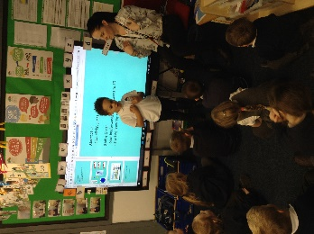
- Stable order - numbers must be said in the same order.
Adults model counting and counting out loud through collaborative play. Counting the number of plates on the table. Counting the number of children at school that day. Counting the number of lunch time bands needed. It is important at this stage that the “counting” has a purpose.

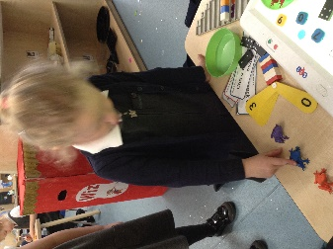
- 1:1 correspondence – one number to one object.
Put all objects to be counted in a line. Touch each object and say the number aloud. Counting the number of knives and forks at a table. Counting the number of cars/trains on a track. Counting how much fruit is in the fruit bowl.

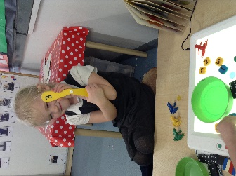
- Cardinality – knowing the last number counted/said is how many there are. We call this the “stop” number at school.
When counting groups of objects, the children know that the last number said means how many objects are in the group. If a child is asked to count out a number of objects from a larger group, they know to stop when they reach the set number and they don’t keep counting on.

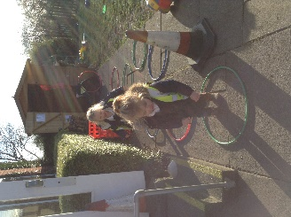
- Abstraction – counting things that cannot be seen or that are not the same
Children do this all of the time They may count the number of skips they are doing with the rope. They may count the number of jumps they can do. Counting different sized objects or collection of things.

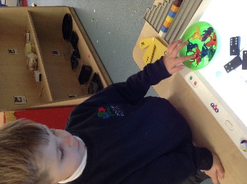
- Order irrelevance – counting all the objects (in whichever order) will result in the same number.
At school we would ask the children to count the teddies. We would then ask the children to count but to make the yellow teddy number 2. We could then extend this by asking the children to count the teddies but to make the red teddy number 4.
This exercise will help the children later when they begin to add larger numbers and order irrelevance becomes a crucial skill.

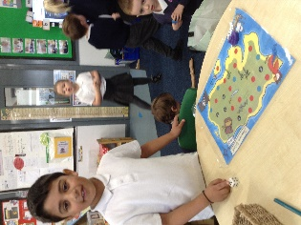
- Subitising – Not counting a small number of objects but knowing the pattern.
The children will have lots of opportunities to practice this skill by playing games, using cards and counting objects. How many can you see? In the future this skill will enable the children to quickly recognise the amount of objects and therefore speeds up the mathematical process.
