Year 1 Homework 19 April 2019

**Practice Makes Perfect – I know doubles and halves.**

You could try

* chanting halves and doubles
* making a quiz to ‘test’ each other
* draw halves and doubles
* find half and double examples in and around your home
* singing doubles/halves songs on YouTube

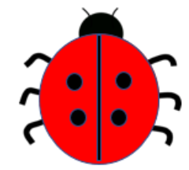 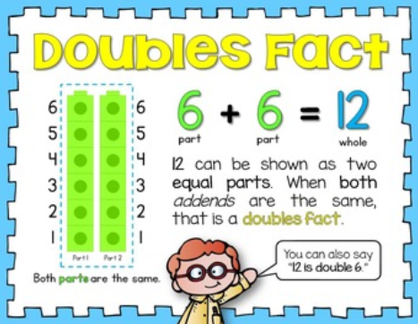

2 is half of 4

half of 4 is 2

**Spellings**

Use last week’s spellings and write your words in fancy writing!

* do
* doing
* have
* having
* go
* going
* jump
* jumping

Year 2 Homework 19 April 2019

**Practice Makes Perfect – I know the division facts for the 2, 5 and 10 times tables.**

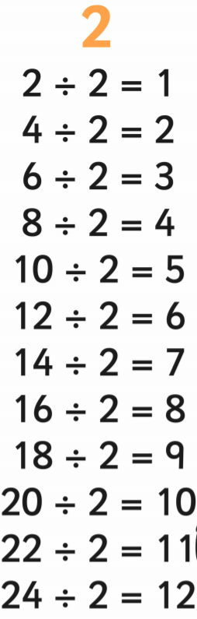 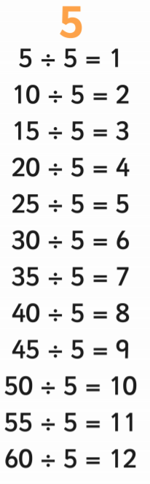 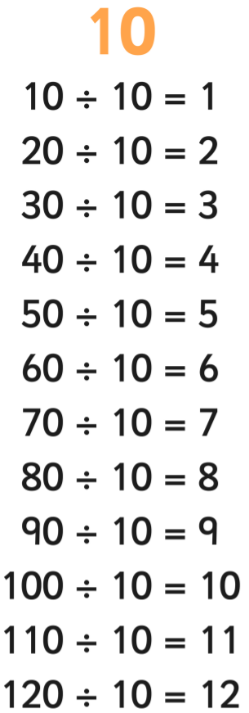

**Spellings**

Use last week’s spellings and write your words in fancy writing!

* excite
* excitement
* state
* statement
* kind
* kindness
* careless
* quickly
* slowly
* lovely