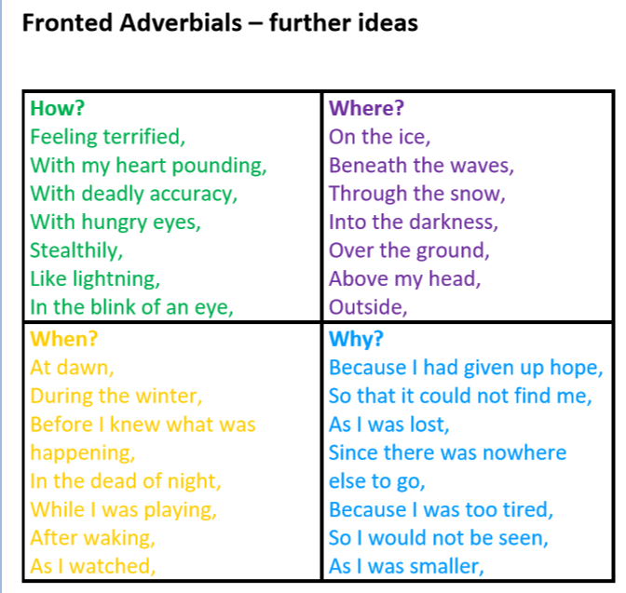

You can use some of these adverbials at the start of your sentences (fronted adverbials).