**Your learning today is to read and interpret tables.**

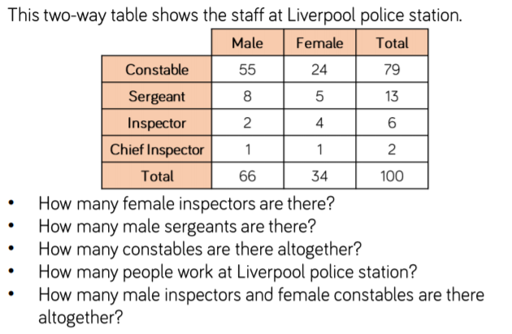

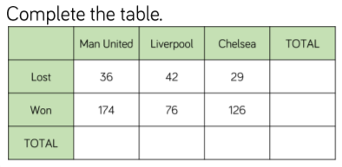

**Challenge**

Write down 5 questions that could be answered by looking at the table above.