Edmund Hillary

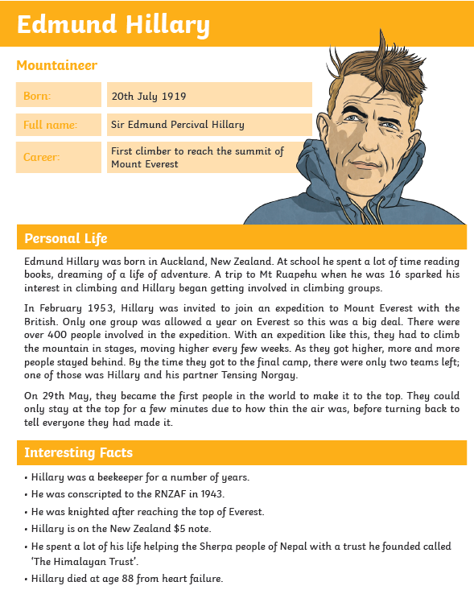

Reading task - Tuesday

1. How many teams were left by the time they got to the final camp? Tick one.

three four two

1. On which date did they reach the top of Mount Everest?
2. True or false?

They only stayed at the top of Mount Everest for a short amount of time because the air was thick.

**Look at the ‘Interesting Facts’ section to answer these questions:**

1. Which interesting hobby did Hillary do in addition to climbing? Circle one.

bee keeping cooking skiing

1. Create your own retrieval question about the Interesting Facts.