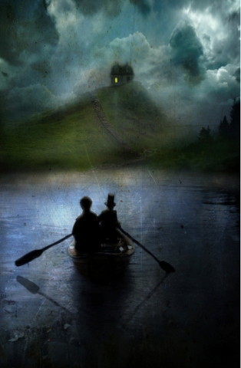**Secret Quest**

Read through this exciting story starter again – we looked at this in detail yesterday. Answer the questions below. What do **you** think is going on? How mysterious …

They knew what had to be done. Time was of the essence.

Quietly placing their oars in the water so as not to make a sound, the two dark figures inched their way across the moonlit lake. Far away on the horizon they could see it…their objective. They had to reach the house. They had to remain undetected.

To their surprise, a light flickered on in one of the rooms. Was someone there? They were told it would be empty. They were told they would be alone. They saw a silhouette pass the glowing window. Who on earth was it? They exchanged an anxious glance. The one in the top hat whispered under his breath. The one with the curly hair shrugged. Beginning to panic, the pair began to paddle faster, oblivious to the splashing sound they were now making.

It did not matter. Time was running out! They only had a matter of minutes…

**Question time!**

Who do you think these two figures are?

Do you think they have good, evil or mischievous intentions? Why?

What are they in such a hurry to do?

What do you think is going on at the house?

Why is there a light on?

Why do you think the characters are surprised to see the light?

**Challenge:**

Could you change some of the vocabulary in this paragraph to change the mood of the text or to make it less dramatic.

E.g.

Quietly placing their oars in the water so as not to make a sound, the two dark figures inched their way across the moonlit lake.

Changes to ….

Quickly plopping their oars in the water because they couldn’t wait to get on their journey, the two friends rowed across the calm lake in the bright sunshine.

Please note: answers will not be given tomorrow as these questions ask for your opinion.