The climb

Look at this picture of the climber. Does it inspire you to want to climb a mountain or go on expedition somewhere? Read the story starter underneath, then answer the questions and complete the sentence challenges.

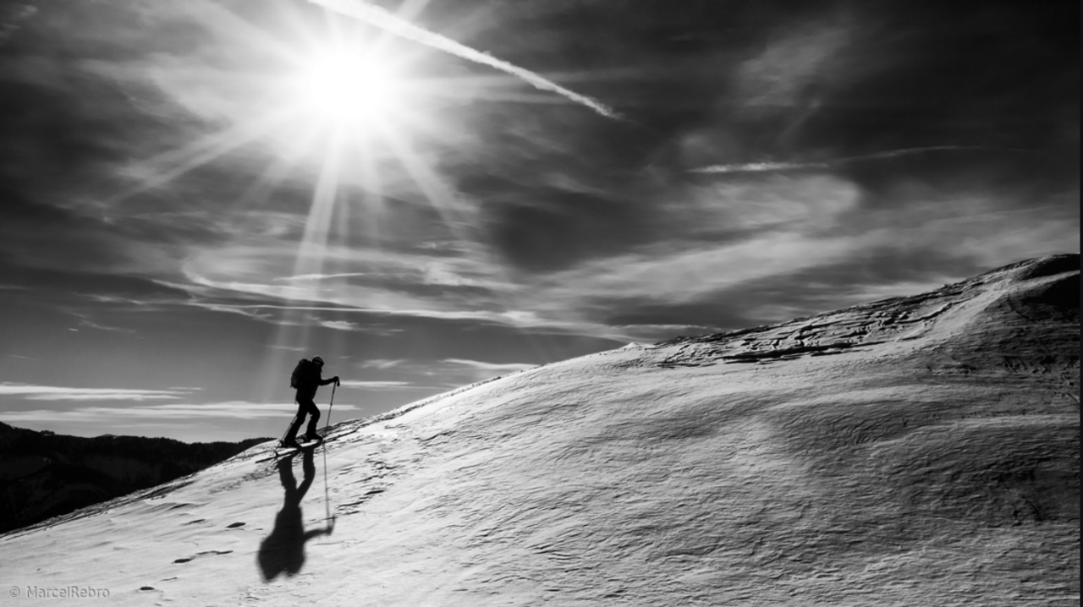

“One step at a time,” the climber muttered to himself as he ascended the escarpment.

The climb had been long and arduous, and he had to be mentally tough to ignore the ache in his legs.

Soon though, he would reach the summit, and all of the pain would be worth it. Climbing Europe’s tallest mountain had been a dream of his ever since he was a child…

escarpment - a long, steep slope, especially one at the edge of a plateau or separating areas of land at different heights

**Question time!**

What does ‘ascended’ mean? What is the opposite of ‘ascended’?

What is an escarpment?

What does ‘arduous’ mean? Can you think of any words that have a similar meaning?

What is the climber wearing on their feet?

What might he find at the summit?

How would a climber prepare for a climb such as this?

What ambitions do you have for your future?

**Sentence challenge!**

Imagine you are climbing the mountain.

Think of adjectives to describe the sun, sky, snow and mountain.

Can you write a description of what you can see around you as you climb?

Can you describe how your body feels?