Things to write about

Some parents and children have been asking for suggestions of things to write about. We’ve been posting three home learning tasks each day, but if you’re looking for more to do and wanting to do some writing, there are a few ideas listed below. There is no expectation that children do these.

If children would like to send their writing to me, I’d love to celebrate it on our class news page!

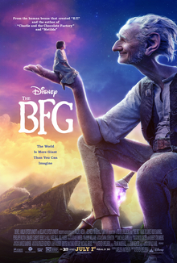
A book/film/TV/music programme review
Share something that you've really enjoyed in the last week or two. Here are some things you could talk about:
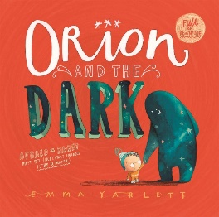
- What's it about? Summarise it (without giving away any secrets!) in a few sentences.
- Who are the main characters? What are they like? Will a reader/audience like them or enjoy hating them?
- Who would most enjoy reading/watching? Why? Give them a recommendation!
- If we liked this, what else might we be interested in watching?
- Finally, give it a star rating out of five.
A recipe
What's your favourite meal? Have you tried something new recently? Learn how to cook it, making sure you get help from adults with parts that might be dangerous or tricky and making notes as you go. Turn this into a recipe to share with your class! You could even take photos to help explain different parts.
Don't forget to include:
- Title - what does the recipe make?
- Cooking time and number of servings
- Introduction (Make the reader want to make the food! Why did you make it? Who will like it?)
- Ingredients (Include measurements and quantities so others can make your food too.)
- Equipment
- Instructions (These should be step by step, using numbers to order them, or sentence starts (fronted adverbials) like 'First,' 'Next,' 'When you've finished chopping,' etc)
(Cooking at home never looks this idyllic for me.)
- Top tips / warnings (What mistakes should we avoid? What made things easier for you?)
Looking at some recipes online or in books can help you get a feel for how to write recipes. BBC Good Food has lots of good ones, in my opinion, but there are plenty others online and I imagine a lot of you may have books at home or have family that know some off by heart. You might find some with all of my list above in, or others that only have some of what I've listed - that's ok!

Write a letter or card to a friend
We all need to feel connected at the moment and I know lots of us are missing seeing our family and friends. Why not write them a little card or send them a letter to let them know you're thinking of them? Everyone loves getting post, right?
You could mention:
- How are you and your family? Are you well? Are you enjoying yourself? Are you bored? Are you busy? Ask about them and their family too.
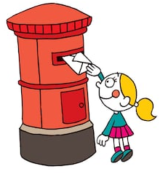
- What have you been doing? What was the best bit? What parts were hard? What did you forget to do? Have you done something new?
- What has been the best meal in the last few days? Why was it so good? What are you looking forward to having?
- Have you been in touch with any of your friends or family recently? What did they have to say? Was anything surprising?
- Have you read or watched anything good recently that they might like or dislike? Recommend something (you could include a full review using the ideas above!) or warn them off something.
- Ask them some questions too so they feel like you want to hear back from them.
Explain how to play your favourite game or do your favourite activity
Have you particularly enjoyed an activity during lockdown? Perhaps you've become an expert at building dens, making animals using origami or making marble runs on the kitchen table. This is a great opportunity to share ideas for what others might enjoy doing, so grab a pencil and get writing!
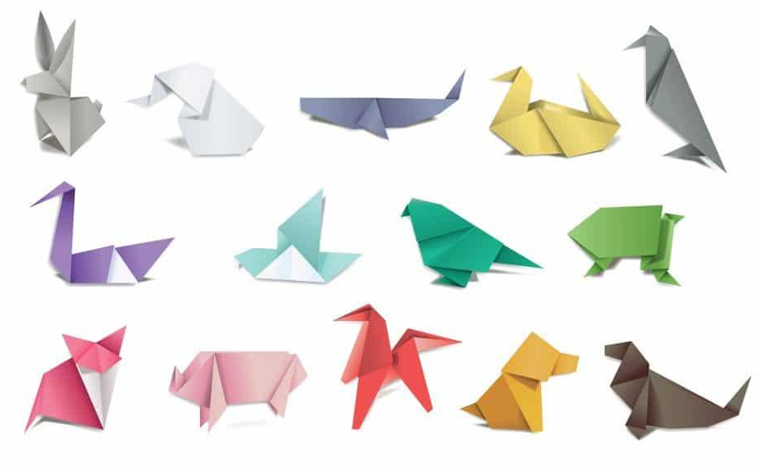
- What's the name of the activity?
- Who would like it?
- What equipment do you need?
- Where is best to do it?
- How do you begin? What next? Give some step by step instructions or explanations.
- Are there any helpful tips? Did you use a book or website to help you?
- What mistakes should people avoid making? Help them to not make them!
Write a story
Storytelling has been part of human history since we first learnt how to speak. Can you create your own story? Sometimes it's fun to make one up from scratch, but sometimes it can be hard to think of what to say. I've made some short videos to explain how to write a story which include parts of what we'd normally do over two or three weeks of lessons in school. There are seven steps, so if you wanted to do this over seven days you could, or you can do it all in a day if you feel inspired!
- Introduction and reading
- Story mapping
- Making it your own
- Plan some description
- Begin writing
- Check it
- Make it look great

