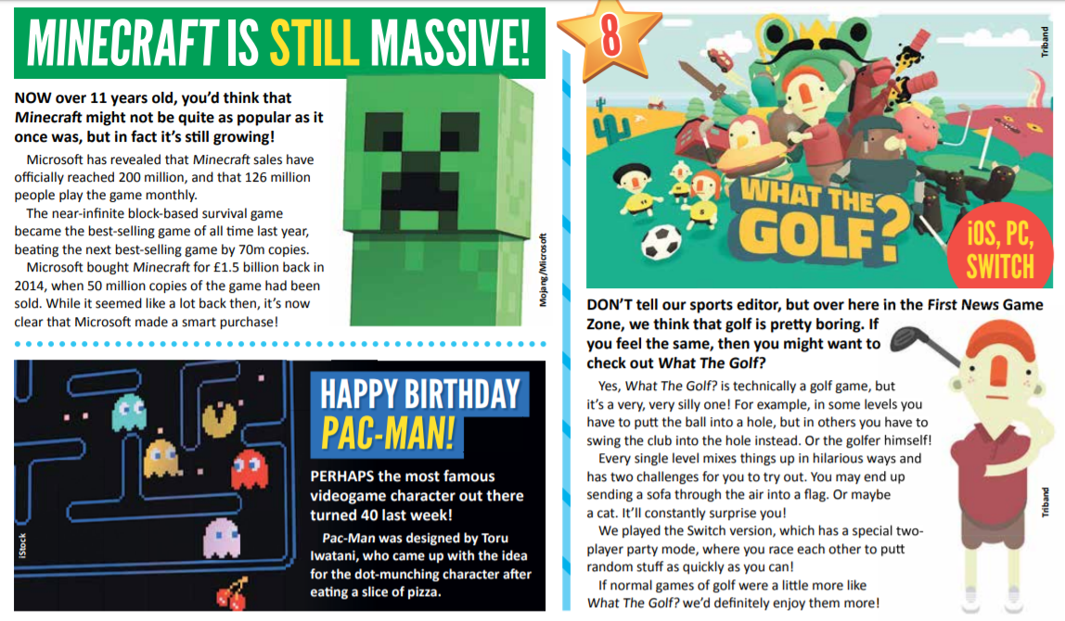

1. According to the text, approximately how many people play Minecraft each month?
2. Using information from the text, put a tick in the correct box to show whether each statement is **true** or **false**.

|  |  |  |
| --- | --- | --- |
|  | **True** | **False** |
| ‘What the Golf?’ does not actually feature the game of golf. |  |  |
| Pac-Man was released 40 years ago. |  |  |
| Apple bought Pac-Man for a huge £1.5 billion in 2014. |  |  |
| According to the text, at least 200 million copies of Minecraft have been bought. |  |  |

1. Look at the Minecraft article.

**Find** and **copy two different** words / phrases that show ***Minecraft*** is still successful.

**1.** ____________________________________

**2.** ____________________________________

1. Write down **three** things that you are told about ***‘What the Golf?’***

**1.**

**2.**

**3.**

1. These sentences are taken from one of the articles above. Fill in the missing word.

You may end up sending a _______ through the air into a flag.

Perhaps the most famous _________ character out there turned 40 last week.

While it seemed a lot back then, it’s now clear that Microsoft ________ a smart purchase.

Or maybe a __________.

Now, create the silliest sentence you can using the missing words.

**Fancy a challenge?**

Use the link to the whole Firstnews paper and have a read. Then, choose an article and create your own retrieval questions for someone else to answer.