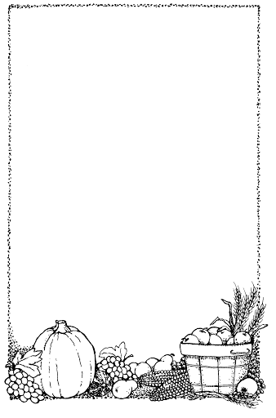
Five Little Pumpkins

Five little pumpkins sitting on a gate.

The first one said, ‘Oo, it’s getting late.’

The second one said, ‘There are witches in the air.’

The third one said, ‘Well I don’t care.’

The fourth one said, ‘Let's run, run, run.’

The fifth one said, ‘Let's have some fun.’

But oooh went the wind, and out went the light,

And five little pumpkins tumbled out of sight.
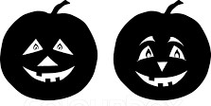

The Poetry Basket www.helicopterstories.co.uk

